AGENDA: Fifty-ninth Annual General Meeting
Saturday 5 December, 2020 at 10.30am
Virtual meeting

1. Introducing the AGM and technical checks – Ally Wilson, Head of External Relations

2. The Chair’s opening remarks

3. Review of the Year – a film introduced by Roger Mortlock

4. Adoption of the Special Resolution

5. Approval of the minutes of the Fifty-eighth Annual General Meeting held on 5th October, 2019

6. Matters arising from the minutes

7. Adoption of the Fifty-ninth Annual Report for the year 2019-2020

8. Adoption of the Accounts for the year ended 31st March 2020

9. Appointment of Auditors for 2020/2021

10. Election of Officers:

a. The following have indicated their willingness to stand for re-election to the Board:

Jane Furze David Jones

b. Nominations for election to the Board:

Richard White Nicola Spencer

11. Our plans for the future including a film on the Estate Review presented by Gareth Parry, Head of Nature’s Recovery.

12. General questions

13. Chair closes the formal AGM meeting and introduces the speaker

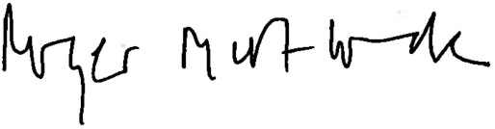
Roger Mortlock, Chief Executive

Following the AGM, we are delighted to welcome our speaker: Dave Goulson who will provide a talk: Gardening to save the planet

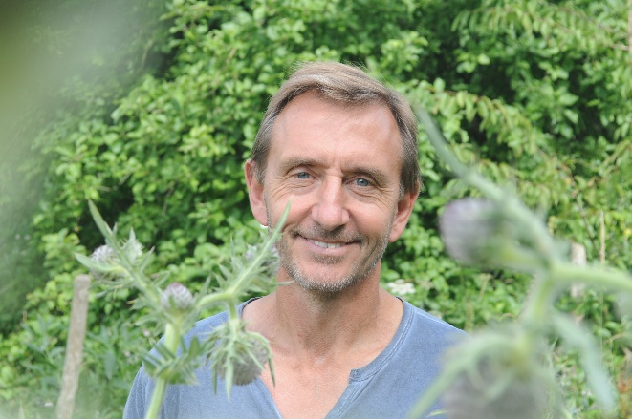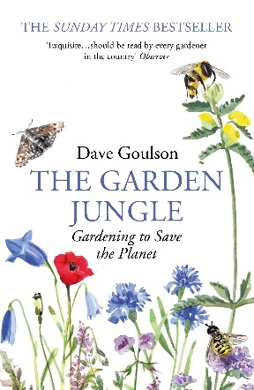

Chances are there are bees, butterflies, hoverflies, moths, woodlice, centipedes, beetles, flies, wasps, spiders and much more, quietly living within a few paces of you. But for all their abundance, insects are in trouble. Global data shows that while humans have doubled our population in the past 40 years, the number of insects has been reduced by almost half. We are witnessing the largest extinction on Earth since the dinosaurs. At GWT we’ve been working with other Wildlife Trusts on a campaign, Action for Insects, to help tackle this crisis.

After a childhood chasing butterflies, Professor Dave Goulson has dedicated his career to exploring the ecology and conservation of bees and other insects. Dave is an award winning conservationist and best-selling author, including a report for the Wildlife Trusts this year on insect declines and why they matter. In his latest book ‘The Garden Jungle’, he shows that with just a few changes, our gardens can become places where we can connect with nature and rediscover where our food comes from. Dave will take us into the fascinating and sometimes weird lives of the creatures who live right under our noses; in compost heaps, under our lawns and beneath the surface of our garden ponds. And he’ll argue that our gardens could collectively form a vast network of tiny nature reserves where humans and wildlife can thrive together.

