Job title: Assistant Catering Manager 1.0 FTE, 37.5 hrs week

Job purpose: To support the Catering Manager in leading and managing the GWT café team at our Robinswood Hill and
Crickley Hill cafes, deputising in their absence, ensuring our café operations are commercially successful, achieve income targets, and maximise profitability. Deliver first-class customer service and exceed visitor expectations. Identify opportunities for innovation and new income streams. Develop a strong, flexible and agile customer-focused café team that reflects the values of GWT. Collaborate with the wider GWT team as required, supporting the delivery of GWT’s programme of events.

Salary: Grade E: Manager, Annual Salary £29.500

Contract: Permanent. 5 days over 7 working pattern to include weekends with occasional evenings as required.

Responsible to: GWT Catering Manager

Liaison with: CEO, Head of Business Operations, Senior Management Team, Finance Team, Facilities Manager,
HR Manager, Learning & Engagement teams, Programming Manager, Volunteer coordinator.

Impact areas:
- Diversifying income and grow our financial reserves
- Engaging and connect more people with nature.

Organisation chart:

Our purpose and values
As humans, we're deeply connected to the natural world — and that world is powerful, dynamic, and resilient. At Gloucestershire Wildlife Trust, we believe that nature offers the solutions to some of the biggest problems we face today, from climate change to our personal wellbeing.

That’s why we work with local communities and partners, using evidence and our hands-on experience, to work in the service of people and wildlife. Whether it's a small project on your street or a big one across the landscape, we believe that every action, big or small, can help shape a brighter, wilder future for us all.

We show how we care for nature, our partners and each other through our values:
🌿 We’re ambitious and dream big — for people and for nature.
🤝 We collaborate, because we can achieve more together.
🌍 We’re inclusive and believe that nature is for everyone.
💚 We act with responsibility for the work we do and the world we’re helping to shape.

Together, we’re growing hope for a wilder future.

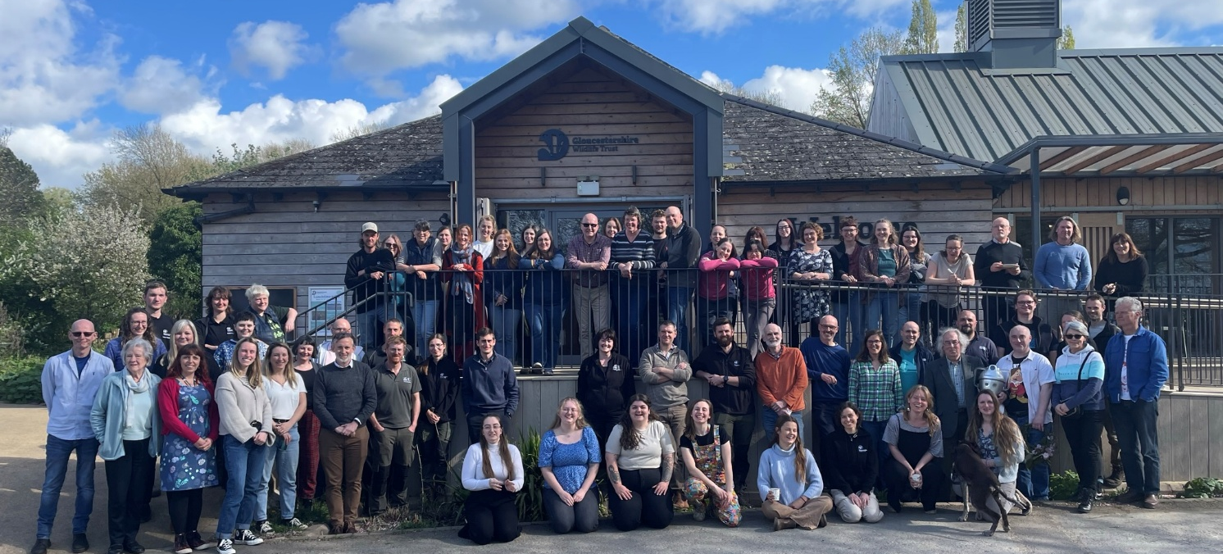

What we do
We are Gloucestershire Wildlife Trust, the largest charity in the county dedicated to nature’s recovery. We want everyone in Gloucestershire to value, enjoy and share wildlife in the county and believe strongly that nature matters, not only in its own right, but for the benefits it brings to people. We aim to play a central role in tackling the ecological and climate emergencies, working closely with local communities and our partners in the county. We manage over 1,000 hectares of nature reserves and work with farmers and landowners across Gloucestershire. Nature’s recovery depends on people and re-connecting their sense of belonging in the natural world. 28,000 members in Gloucestershire support our work, with hundreds regularly volunteering time, support and energy.
Our 2030 strategy Growing Hope For A Wilder Future: Bringing Nature Back is ambitious, but we believe we can deliver it by:
- Ensuring that GWT is fit for the future
- Creating bigger, better, more & connected landscapes for nature
- Connecting people with a sense of belonging in nature

About the role:
- Support the Catering Manager in leading a culture of exceptional customer service across GWT’s cafes, regularly reviewing the quality and standard of our offer and service, whilst helping to shape and adhere to GWT brand standards.
- Maintaining consistently high standards of customer experience across GWT cafes and resolving day to day issues according to GWT policies and procedures.
- Manage and deliver the financial performance of the cafés, meeting and exceeding sales targets while controlling profitability through effective labour, stock and cost controls and management of suppliers.
- Line management of the café team, including café assistants and where applicable catering volunteers.
- Understand the commercial drivers of cafés performance and identify opportunities to increase income, explore new revenue streams, and drive bottom-line contribution.
- Support the Catering Manager to create, lead and develop a strong, cohesive and customer-focused team, with regular feedback, objective-setting, training and performance reviews.
- Identify and manage risk, complying with all relevant Food Safety and Health & Safety legislation, and ensuring all compliance and monitoring processes are followed to minimise the risk to staff, members of the public and contractors.
- Assist in leading the team to engage with our visitors and make the link between our cafés and how they support the work of GWT, seeking and acting upon feedback from our visitors to improve our offer - First point of contact in many cases between GWT and members of the public / customers
- Represent the catering department at wider GWT meetings and team functions in the Catering Manager’s absence, communicating and cascading GWT policies to the catering team as required.
- Support GWT’s wider activity across but not limited to RWH and CH and other sites as required, including delivery of GWT’s programme of events and activities, working in collaboration with the programming team to identify and realise opportunities to maximise income.

About you
- Experience of leading and delivering a culture of great service within a similar operation.
- A track-record of meeting and exceeding financial and customer service-based targets.
- Solid understanding and experience of assessing and managing risk, knowledge of effectively managing Food Safety, Health & Safety and compliance requirements. Food and Health & Safety to Level 3 is desirable, though this training will be provided.
- Experience and understanding of effective stock control, managing a GP%, liaising with and managing suppliers.
- Excellent people management skills, team development, motivation and communication.
- Experience of setting personal objectives and conducting effective appraisals, team meetings and 1-2-1s.
- Strong financial acumen, demonstrable experience of setting and managing budgets to deliver income, labour and margin targets.
- Comfortable dealing with a diverse range of stakeholders both internal and external
- Good written and verbal communication skills
- Competent IT skills and experience in using Food & Beverage (F&B) management systems
- Ability to use digital media and marketing channels
- Good knowledge of F&B best practice and current trends within the F&B industry.

Qualities:
- Enthusiasm, motivation and dedication
- Proactive, highly flexible and comfortable with change
- Personable and approachable, but not afraid to have difficult conversation when needed
- Ability to engage confidently and professionally with a diverse array of stakeholders
- High level of focus and attention to detail
- Self-disciplined, self-motivated and self-confident
- Professional outlook and approach
- Personal commitment to nature conservation and sustainable living
Equality, Diversity and Inclusion
Gloucestershire Wildlife Trust is committed to encouraging equality, diversity and inclusion among its workforce, and eliminating unlawful discrimination, harassment and victimisation. The Trust’s policy is to provide equality, fairness and respect for all staff, whether temporary, part-time or full-time; ensure no unlawful discrimination against the Equality Act 2010 protected characteristics of age, disability, gender reassignment, marriage and civil partnership, pregnancy and maternity, race (including colour, nationality, and ethnic or national origin), religion or belief, sex and sexual orientation; and to oppose and avoid all forms of unlawful discrimination. A full copy of the policy is available on request.

Terms of Employment
Due to the nature of the Trust’s work, occasional evening or weekend work may be necessary for which time off in lieu is given. A contributory pension scheme is in operation and the post holder is entitled to 25 days paid leave per year pro rata in addition to public holidays and Christmas closing period.

The duties and responsibilities outlined above do not represent the full range of duties the post holder may be expected to carry out. It is recognised that the duties of all posts may be subject to change from time to time, and therefore alterations to duties and responsibilities can be expected. The post holder will be consulted by their line manager prior to any proposed major changes to duties and responsibilities and reasonable notice will be given before implementation.

