Job title: Seasonal HabiMap Assistant

Job purpose: To facilitate large scale volunteer participation within the HabiMap Citizen Science habitat survey programme across Gloucestershire and lead targeted surveys.

Salary: £13.45 per hour (real living wage)

Contract: Fixed term - 13 weeks between May and August, start and finish dates to be confirmed with successful candidate

Responsible to: HabiMap Programme Officer

Responsible for: Volunteers

Liaison with: HabiMap Programme Officer, Head of Ecological Evidence, Citizen Science and Evidence Officer (CSEO), Volunteer Coordinator, Farm Advice Officer, Lead Reserves Managers, GCER Development Manager, Community Action Manager, GIS Officer, Cotswold National Landscapes, Nation Trails

Impact areas for the role:
- Embed evidence in decision making, though provision of accurate data
- Deliver landscape scale solutions by providing underpinning evidence for decision making.

Organisation chart:

Our purpose and values
As humans, we're deeply connected to the natural world — and that world is powerful, dynamic, and resilient. At Gloucestershire Wildlife Trust, we believe that nature offers the solutions to some of the biggest problems we face today, from climate change to our personal wellbeing.

That’s why we work with local communities and partners, using evidence and our hands-on experience, to work in the service of people and wildlife. Whether it's a small project on your street or a big one across the landscape, we believe that every action, big or small, can help shape a brighter, wilder future for us all.

We show how we care for nature, our partners and each other through our values:
🌿 We’re ambitious and dream big — for people and for nature.
🤝 We collaborate, because we can achieve more together.
🌍 We’re inclusive and believe that nature is for everyone.
💚 We act with responsibility for the work we do and the world we’re helping to shape.

Together, we’re growing hope for a wilder future.

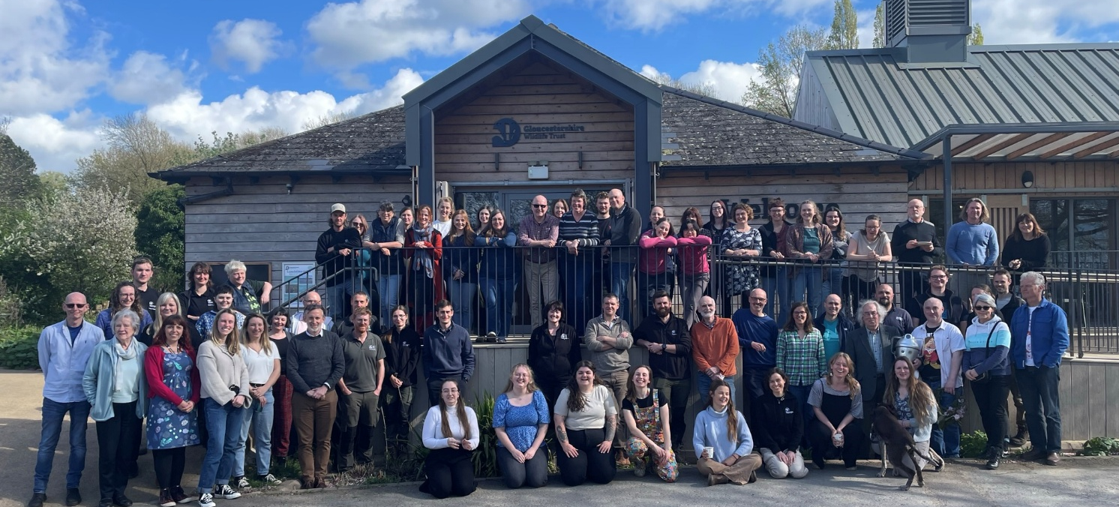

What we do
We are Gloucestershire Wildlife Trust, the largest charity in the county dedicated to nature’s recovery. We want everyone in Gloucestershire to value, enjoy and share wildlife in the county and believe strongly that nature matters, not only in its own right, but for the benefits it brings to people. We aim to play a central role in tackling the ecological and climate emergencies, working closely with local communities and our partners in the county. We manage over 1,000 hectares of nature reserves and work with farmers and landowners across Gloucestershire. Nature’s recovery depends on people and re-connecting their sense of belonging in the natural world. 28,000 members in Gloucestershire support our work, with hundreds regularly volunteering time, support and energy.
Our 2030 strategy Growing Hope For A Wilder Future: Bringing Nature Back is ambitious, but we believe we can deliver it by:
- Ensuring that GWT is fit for the future
- Creating bigger, better, more & connected landscapes for nature
- Connecting people with a sense of belonging in nature

Introduction to the role:
The HabiMap programme is designed to improve the underlying habitat data used to develop the NRN and deliver nature restoration activities on the ground, aiming to carry out UK habitat classification (UKHab) habitat survey on a rolling program across the whole of Gloucestershire.

This will be impossible to achieve without the mass engagement and support of volunteers, landowners and local communities, and effective processing of incoming data.

Key outcomes are:

- Support coordination of safe and effective collaborative volunteer effort against a planned survey programme to deliver a smooth overall experience for volunteers and staff.

- Support development and delivery of internal HabiMap data procedures and processes.

- Support engagement of communities and organisations in the HabiMap programme.

Outline of main responsibilities
The role will work closely with the HabiMap Programme Officer to:

- Support the induction and ongoing collaboration of volunteers involved in the project.
- Support timely administration, data management, GIS mapping, communications with volunteers and social media posts and responses.
- Support the provision of volunteer training e.g., organisation and preparation.
- Support HabiMap Programme Officer in coordinating the HabiMap Programme including preparing written resources and maps for volunteers and basic quality control of incoming data.
- Liaise with partners and landowners to gain survey permission for the HabiMap programme.
- Support HabiMap Programme Officer in surveying habitats across the county using the UKHab field key and lead volunteers mapping the Cotswold National trail.
- Work with GWT colleagues to provide exceptional volunteer management that enables volunteers to carry out survey work safely and on time.

About you:

Qualifications:
- Demonstrate experience or qualifications equivalent to UK A level, in conservation management, ecology or related discipline.

Experience and knowledge:
Essential:

- Experience of time management for self and others
- Experience of data management
- An understanding of GIS
- A demonstratable interest in botany
- Health and Safety awareness and ability to follow risk management procedures.
- Knowledge of UKHab (the UK Habitat Classification)

Desirable:
- Understanding of the need for compliance with GDPR (General Data Protection Regulation)
- Previous experience of volunteering or working with volunteers
- Experience of UKHab surveying and/or botanical surveys
- Experience of organising and running events.

Skills:
Essential:
- Excellent communication, relationship management & cross team working skills.
- Highly organised, with strong work planning skills and ability to prioritize.
- Highly competent on Microsoft Office, especially Excel.
- Self-motivated, able to problem solve and use own initiative.
- Excellent oral and written presentation skills.
- Good attention to detail.
- Full driving licence and own transport (or ability to get to survey locations).

Desirable:
- Experience of GIS mapping software
- Knowledge of habitats and habitat management methods

Qualities:
Essential:
- Highly productive and comfortable working in a fast-paced environment.
- Pragmatism, tact, and diplomacy, with an ability to work with a wide variety of people at all levels.
- Confident, motivated, and dedicated.

Desirable:
- Personal commitment to the environment and nature’s recovery.
- A reasonable level of personal fitness.

Equality, Diversity and Inclusion
Gloucestershire Wildlife Trust is committed to encouraging equality, diversity and inclusion among its workforce, and eliminating unlawful discrimination, harassment and victimisation. The Trust’s policy is to provide equality, fairness and respect for all staff, whether temporary, part-time or full-time; ensure no unlawful discrimination against the Equality Act 2010 protected characteristics of age, disability, gender reassignment, marriage and civil partnership, pregnancy and maternity, race (including colour, nationality, and ethnic or national origin), religion or belief, sex and sexual orientation; and to oppose and avoid all forms of unlawful discrimination. A full copy of the policy is available on request.

Terms of Employment
Due to the nature of the Trust’s work, occasional evening or weekend work may be necessary for which time off in lieu is given. A contributory pension scheme is in operation and the post holder is entitled to 25 days paid leave per year pro rata in addition to public holidays and Christmas closing period.
The duties and responsibilities outlined above do not represent the full range of duties the post holder may be expected to carry out. It is recognised that the duties of all posts may be subject to change from time to time, and therefore alterations to duties and responsibilities can be expected. The post holder will be consulted by their line manager prior to any proposed major changes to duties and responsibilities and reasonable notice will be given before implementation.
Gloucestershire Wildlife Trust Registered Charity Number 232580

