Role title | Land Management Wild Trainee (voluntary)
Role location | Based at Crickley Hill, Gloucestershire, GL4 8JY.  Working across 30 nature reserves throughout the east of the county, from Stroud to Bourton-on-the-Water to Lower Woods.
Role purpose | This role is intended to provide experience and skills necessary to pursue a career in UK wildlife conservation and habitat management. Former land management trainees have gained paid jobs in the sector following the end of the traineeship.  Trainees in the Land Management team focus on:  - Practical habitat management of species-rich Cotswold limestone grassland and ancient woodlands.  - Maintenance of infrastructure such as fences, gates and footpaths.  Trainees will also gain a broad and flexible range of experience with other departments within the Trust, plus access to relevant sector specific internal and external training, events, conferences and projects.
Time Commitment | Minimum 21 hours a week for 12 months.  Preferred 3 days: Tuesdays, Wednesdays and Thursdays 08.30 to 16.30 and occasional evenings and weekends by arrangement. These days can be flexible upon arrangement.  15 days (5 weeks) allowance to cover pre-arranged holiday absence.
Reporting to | Trainees will be mentored by Land Management Officers and line managed by Land Manager (East).
Essential | Due to lack of public transport, own transport to Crickley Hill nature reserve is essential.  Reasonable expenses for mileage, lunches and kit, etc. is offered.

Introducing Gloucestershire Wildlife Trust
We are Gloucestershire Wildlife Trust – the largest membership organisation in the county dedicated to local wildlife. We aim to play a central role in tackling the ecological and climate emergencies in Gloucestershire, working closely with local communities and our partners.
Our purpose is to ensure nature’s recovery together with the people of Gloucestershire.
Our vision is for a natural world in recovery, where nature-based solutions are tackling the climate crisis and people are taking action for wildlife.
This needs 30% of the land supporting nature’s recovery by 2030 and unlocking the potential of nature-based solutions to mitigate and adapt to the impacts of climate change.
At the Gloucestershire Wildlife Trust, we believe in supporting and caring for all our colleagues with honesty. We are rooted in our communities and our aim is to make nature inclusive for all.
We pride ourselves in being champions for wildlife, advocating passion and pioneering sustainable methods for natures recovery.
Gloucestershire Wildlife Trust expects its staff, paid and unpaid, to carry out their duties in a way which consistently exceeds the regulations and expectations of society at large in matters ethical and environmental.

Introduction to the role

Land Management Trainees will be based in our Land Management East Team. The largest part of trainees’ time will be spent undertaking practical, physical tasks, outdoors on nature reserves in Gloucestershire. This work helps restore and improve habitats for wildlife.

Role benefits / Training Opportunities

This role would suit people looking to progress towards a career in the UK wildlife sector.
The successful trainee will:
- Agree a structured individual development plan with their mentor and develop technical and soft skills while gradually taking on responsibility as they gain experience.
- Undertake a substantial amount of relevant training, including externally certified Brushcutter and Outdoor First Aid.
- Develop softer skills such as leadership, volunteer management, networking, project management, landholder and stakeholder engagement.
- Work alongside other GWT teams to gain a broad range of experience, including ecological evidence, farm advice, communications, ecological consultancy, project development, fundraising and protected species surveys.
- The opportunity to organise bespoke ‘experience’ days with other departments to form a broader understanding of cross-conservation-organisation activities
- Benefit from additional financial support for kit, training, conferences etc.
- Have access to the Wildlife Trusts network and the wider UK Wildlife sector, including training and events.
- Have specialist job application and interview support sessions.
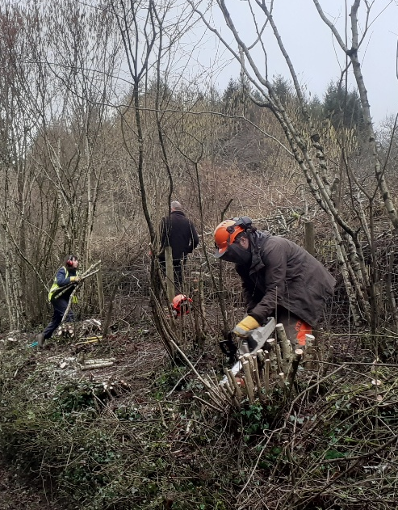
Outline of Main Activities

- Habitat management tasks on species-rich limestone grassland, ancient woodlands and meadows (e.g. meadow cutting, scrub removal, invasive species control).
- Practical reserve management including the repair and installation of site infrastructure such as gates fences, steps, and footpath maintenance.
- Leading volunteers in practical reserve management and habitat management tasks on reserves.
- Training in the use and maintenance of tools, power tools, Wildlife Trust vehicles and trailers.
- Occasionally assisting other departments conducting surveys, analysing survey data, and generating social media content.
- Additional opportunities to assist with events, guided walks and wildlife surveys, some of which may be outside of core working hours.
- Livestock care and husbandry.
- Wilder landscapes projects such as natural flood management work.
- Experiencing other departments within the Trust to gain a wider knowledge and understanding of conservation charity operations, including training and taster days with the other Wild Trainees.

Person Specification
Essential criteria
- Aged 18 to 25 - due to funder requirements
- Highly motivated by an interest in UK wildlife conservation and desire to work in the sector.
- Own transport/driving licence and ability to reliably get to Crickley Hill without public transport.
- Physically fit enough to work outdoors all day on rough terrain.
- Willingness to use power tools.
- Health and Safety awareness and ability to follow risk management procedures.
- Willingness to supervise and lead volunteers, after training
- Willingness to learn a collaborative style and confidence to communicate with a wide variety of people on a professional level.
- Highly organised and productive, with strong work planning skills and ability to use own initiative.
- Strong attention to detail.
Desirable criteria
- Have had experience volunteering for a conservation organisation or enterprise
- Can demonstrate experience or qualifications equivalent to UK A level, in wildlife, conservation management, ecology or related discipline.
- Entry level or above wildlife ID skills or openness to developing them
- Experience of volunteering / Citizen Science
- Experience of organising or helping at small events
- Knowledge of habitats and habitat management methods
- Mechanical aptitude
- Full driving licence and willingness to drive Wildlife Trust vehicles
- Good IT skills

Equality, Diversity and Inclusion

Gloucestershire Wildlife Trust is committed to encouraging equality, diversity and inclusion among its workforce, and eliminating unlawful discrimination, harassment and victimisation.
The Trust’s policy is to provide equality, fairness and respect for all staff and volunteers, ensure no unlawful discrimination against the Equality Act 2010 protected characteristics of age, disability, gender reassignment, marriage and civil partnership, pregnancy and maternity, race (including colour, nationality, and ethnic or national origin), religion or belief, sex and sexual orientation; and to oppose and avoid all forms of unlawful discrimination.
A full copy of the policy is available on request.

