Job title: Volunteer Coordinator

Job purpose: To coordinate a team of over 600 volunteers supporting them throughout their journey with Gloucestershire Wildlife Trust, to ensure they enjoy their time with us and that there is a progression route to develop skills, experience and take action for nature.

Salary: £ 26,734

Contract: Permanent FTE

Responsible to: Community Action Manager

Responsible for: Team of 600+ Volunteers

Liaison with: All GWT Teams, Royal Society of Wildlife Trusts Central team, local Volunteer networks

Impact areas for the role:
- Grow GWT’s supporter base
- Engage and Connect with Nature
- Enable Meaningful Action for Nature
Organisation chart:

Our purpose and values
As humans, we're deeply connected to the natural world — and that world is powerful, dynamic, and resilient. At Gloucestershire Wildlife Trust, we believe that nature offers the solutions to some of the biggest problems we face today, from climate change to our personal wellbeing.

That’s why we work with local communities and partners, using evidence and our hands-on experience, to work in the service of people and wildlife. Whether it's a small project on your street or a big one across the landscape, we believe that every action, big or small, can help shape a brighter, wilder future for us all.

We show how we care for nature, our partners and each other through our values:
🌿 We’re ambitious and dream big — for people and for nature.
🤝 We collaborate, because we can achieve more together.
🌍 We’re inclusive and believe that nature is for everyone.
💚 We act with responsibility for the work we do and the world we’re helping to shape.

Together, we’re growing hope for a wilder future.

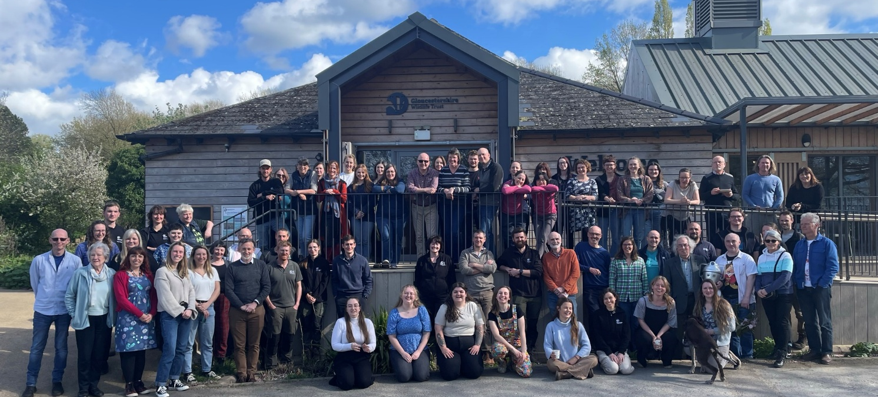

What we do
We are Gloucestershire Wildlife Trust, the largest charity in the county dedicated to nature’s recovery. We want everyone in Gloucestershire to value, enjoy and share wildlife in the county and believe strongly that nature matters, not only in its own right, but for the benefits it brings to people. We aim to play a central role in tackling the ecological and climate emergencies, working closely with local communities and our partners in the county. We manage over 1,000 hectares of nature reserves and work with farmers and landowners across Gloucestershire. Nature’s recovery depends on people and re-connecting their sense of belonging in the natural world. 28,000 members in Gloucestershire support our work, with hundreds regularly volunteering time, support and energy.
Our 2030 strategy Growing Hope For A Wilder Future: Bringing Nature Back is ambitious, but we believe we can deliver it by:
- Ensuring that GWT is fit for the future
- Creating bigger, better, more & connected landscapes for nature
- Connecting people with a sense of belonging in nature

Outline of main responsibilities:
- Volunteer retention and satisfaction - organise annual festive and summer celebration events for volunteers, maintain a regular newsletter and seek out appropriate reward opportunities for volunteers ensuring the volunteer offer remains diverse and satisfying for longstanding volunteers.
- Grow our supporter base through the recruitment of a diverse pool of new volunteers, prioritising high-quality delivery, and providing or arranging training where necessary. Working with staff to identify and develop a range of volunteer opportunities throughout the Trust.
- Champion and advocate for volunteering internally - helping to adapt staff processes and training to ensure that the importance of volunteering is recognised and catered for. Take the lead on internal volunteer problem solving.
- Own and manage Team Kinetic - our online volunteer management system.
- Policies and procedures - update written materials and documentation on policy and procedures as required. Maintain accurate training records.
- Practical supervision of volunteers and volunteer teams at gateway sites. Liason with external volunteer groups.
- Demonstrate the impact of volunteering - track the impact of Volunteering by ensuring accurate records are maintained via Team Kinetic. Collect stories and case studies regarding volunteering
- Project Delivery - work with Community Action Manager to deliver and develop funded projects that improve our volunteering offer. Supply volunteering data and evaluation for to support funding bid writing and reporting. Report regularly on progress.
- Data Management - Ensure that up to date, accurate records of volunteers and associated volunteering activities across the Trust are kept accessible to those who need them and that record keeping complies with GDPR legislation and safeguarding best practice.
- Budget Tracking - Track expenditure of an agreed volunteer budget, process volunteer expenses

About you:

Need to have:

- Good people skills, able to deal with a diverse range of people from all walks of life.
- Experience of working with / managing volunteers
- Understanding of volunteer legislation and policies
- Excellent communicator – written and verbal
Nice to Have
- Good working knowledge of GDPR
- Understanding of Safeguarding vulnerable adults
- Experience of project management
- Experience of event organising
- Understanding of health and safety legislation and using risk assessments
- Conservation-related degree or equivalent
- Previous experience of leading practical volunteer groups
- Developing and delivering funded volunteering projects

Skills:
- Good IT skills, ideally experience of managing volunteer databases
- Excellent partnership working and networking
- Problem solving skills
- Good presentation skills
Qualities:
- Self-motivated and enthusiastic
- Excellent at cross team working
- High degree of initiative and self-reliance
- Good attention to detail
- Personal commitment to the environment and wildlife conservation
Equality, Diversity and Inclusion
Gloucestershire Wildlife Trust is committed to encouraging equality, diversity and inclusion among its workforce, and eliminating unlawful discrimination, harassment and victimisation. The Trust’s policy is to provide equality, fairness and respect for all staff, whether temporary, part-time or full-time; ensure no unlawful discrimination against the Equality Act 2010 protected characteristics of age, disability, gender reassignment, marriage and civil partnership, pregnancy and maternity, race (including colour, nationality, and ethnic or national origin), religion or belief, sex and sexual orientation; and to oppose and avoid all forms of unlawful discrimination. A full copy of the policy is available on request.

Terms of Employment
Due to the nature of the Trust’s work, occasional evening or weekend work may be necessary for which time off in lieu is given. A contributory pension scheme is in operation and the post holder is entitled to 25 days paid leave per year pro rata in addition to public holidays and Christmas closing period.
The duties and responsibilities outlined above do not represent the full range of duties the post holder may be expected to carry out. It is recognised that the duties of all posts may be subject to change from time to time, and therefore alterations to duties and responsibilities can be expected. The post holder will be consulted by their line manager prior to any proposed major changes to duties and responsibilities and reasonable notice will be given before implementation.
Gloucestershire Wildlife Trust Registered Charity Number 232580

