Job title: Communications Officer

Job purpose: You will support the delivery of communications through key channels, including social media, email marketing, website content and the Trust’s magazine, ensuring content is accurate, engaging and aligned with organisational priorities.

You will create compelling, audience-focused content that brings the Trust’s conservation work, campaigns and community engagement to life, helping to raise awareness, build support and encourage action for nature. The role also leads on internal communications, ensuring staff and trustees are well informed and connected

Salary: £25,235 pa

Contract: Full-time (35 hours per week). Fixed term for six months with possibility of permanent contract.

Responsible to: Communications and Marketing Manager

Liaison with: Supporter development team, land management teams, community engagement advisor, senior management team, engagement team, education and learning team, wilder landscapes team, landscape recovery team, evidence team, business operations team.

Our purpose and values
As humans, we're deeply connected to the natural world — and that world is powerful, dynamic, and resilient. At Gloucestershire Wildlife Trust, we believe that nature offers the solutions to some of the biggest problems we face today, from climate change to our personal wellbeing.

That’s why we work with local communities and partners, using evidence and our hands-on experience, to work in the service of people and wildlife. Whether it's a small project on your street or a big one across the landscape, we believe that every action, big or small, can help shape a brighter, wilder future for us all.

We show how we care for nature, our partners and each other through our values:
🌿 We’re ambitious and dream big — for people and for nature.
🤝 We collaborate, because we can achieve more together.
🌍 We’re inclusive and believe that nature is for everyone.
💚 We act with responsibility for the work we do and the world we’re helping to shape.

Together, we’re growing hope for a wilder future.

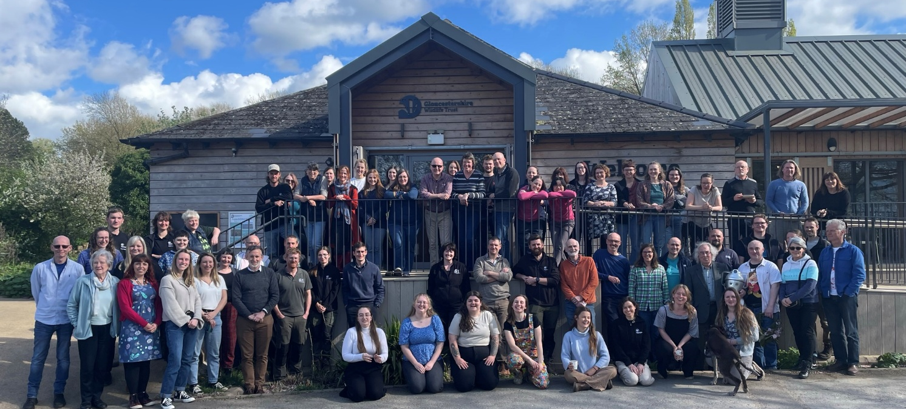

What we do
We are Gloucestershire Wildlife Trust, the largest charity in the county dedicated to nature’s recovery. We want everyone in Gloucestershire to value, enjoy and share wildlife in the county and believe strongly that nature matters, not only in its own right, but for the benefits it brings to people. We aim to play a central role in tackling the ecological and climate emergencies, working closely with local communities and our partners in the county. We manage over 1,000 hectares of nature reserves and work with farmers and landowners across Gloucestershire. Nature’s recovery depends on people and re-connecting their sense of belonging in the natural world. 28,000 members in Gloucestershire support our work, with hundreds regularly volunteering time, support and energy.
Our 2030 strategy Growing Hope for a Wilder Future: Bringing Nature Back is ambitious, but we believe we can deliver it by:
- Ensuring that GWT is fit for the future
- Creating bigger, better, more & connected landscapes for nature
- Connecting people with a sense of belonging in nature

Outline of main responsibilities:
- Supporting day-to-day production and delivery of content across social media channels and email newsletters, ensuring engaging written and visual content
- Assisting with basic website updates, ensuring content is accurate, accessible and up to date, and flagging issues to the Communications Coordinator/Manager.
- Supporting the production of supporter development products, including the magazine, appeals and campaigns, by drafting copy, sourcing images and coordinating feedback.
- Assisting with delivery of annual photo competition, working to deadline and completing tasks as required
- Monitor marketing inbox daily, responding to enquiries and forwarding on filming and media enquiries to communications manager
- Coordinating internal communications – ensuring the intranet is up to date, sending out weekly internal newsletters and ensuring that colleagues have straightforward access to the information and resources they need.

About you:

You must be creative and proactive, with an interest in wildlife and the natural environment. You will work flexibly and professionally, managing multiple projects at once and delivering to tight deadlines. A self-starter, you will enjoy developing and improving internal communications approaches and initiatives.

You will have excellent communication skills. You are comfortable juggling multiple priorities and bring a proactive, solutions-focused approach to your work. You will be approachable and professional, and able to build strong working relationships across the organisation.

You work just as effectively independently as you do as part of a team and are committed to collaborating with a wide range of staff and volunteers from across the organisation.

Need to have:

- Driving license
- Experience of working in a communications environment, administrative role or similar.
- Experience copywriting and editing for marketing and/or communicative purposes
- Excellent written and verbal communication skills
- Demonstrated ability to develop collaborative working relationships across an organisation
Nice to have
- A degree or relevant qualification
- Previous experience within a charity or conservation-based organisation
Equality, Diversity and Inclusion
Gloucestershire Wildlife Trust is committed to encouraging equality, diversity and inclusion among its workforce, and eliminating unlawful discrimination, harassment and victimisation. The Trust’s policy is to provide equality, fairness and respect for all staff, whether temporary, part-time or full-time; ensure no unlawful discrimination against the Equality Act 2010 protected characteristics of age, disability, gender reassignment, marriage and civil partnership, pregnancy and maternity, race (including colour, nationality, and ethnic or national origin), religion or belief, sex and sexual orientation; and to oppose and avoid all forms of unlawful discrimination. A full copy of the policy is available on request.

Terms of Employment
Due to the nature of the Trust’s work, occasional evening or weekend work may be necessary for which time off in lieu is given. A contributory pension scheme is in operation and the post holder is entitled to 25 days paid leave per year pro rata in addition to public holidays and Christmas closing period.
The duties and responsibilities outlined above do not represent the full range of duties the post holder may be expected to carry out. It is recognised that the duties of all posts may be subject to change from time to time, and therefore alterations to duties and responsibilities can be expected. The post holder will be consulted by their line manager prior to any proposed major changes to duties and responsibilities and reasonable notice will be given before implementation.
Gloucestershire Wildlife Trust Registered Charity Number 232580

